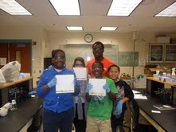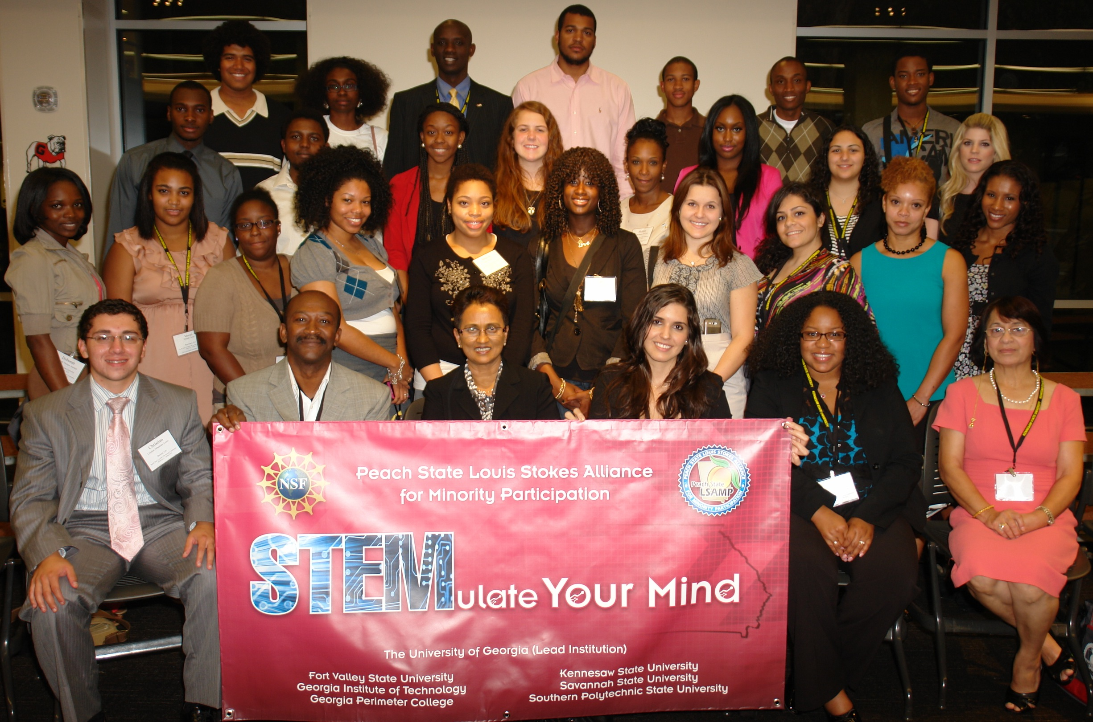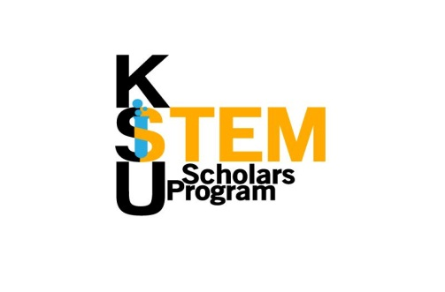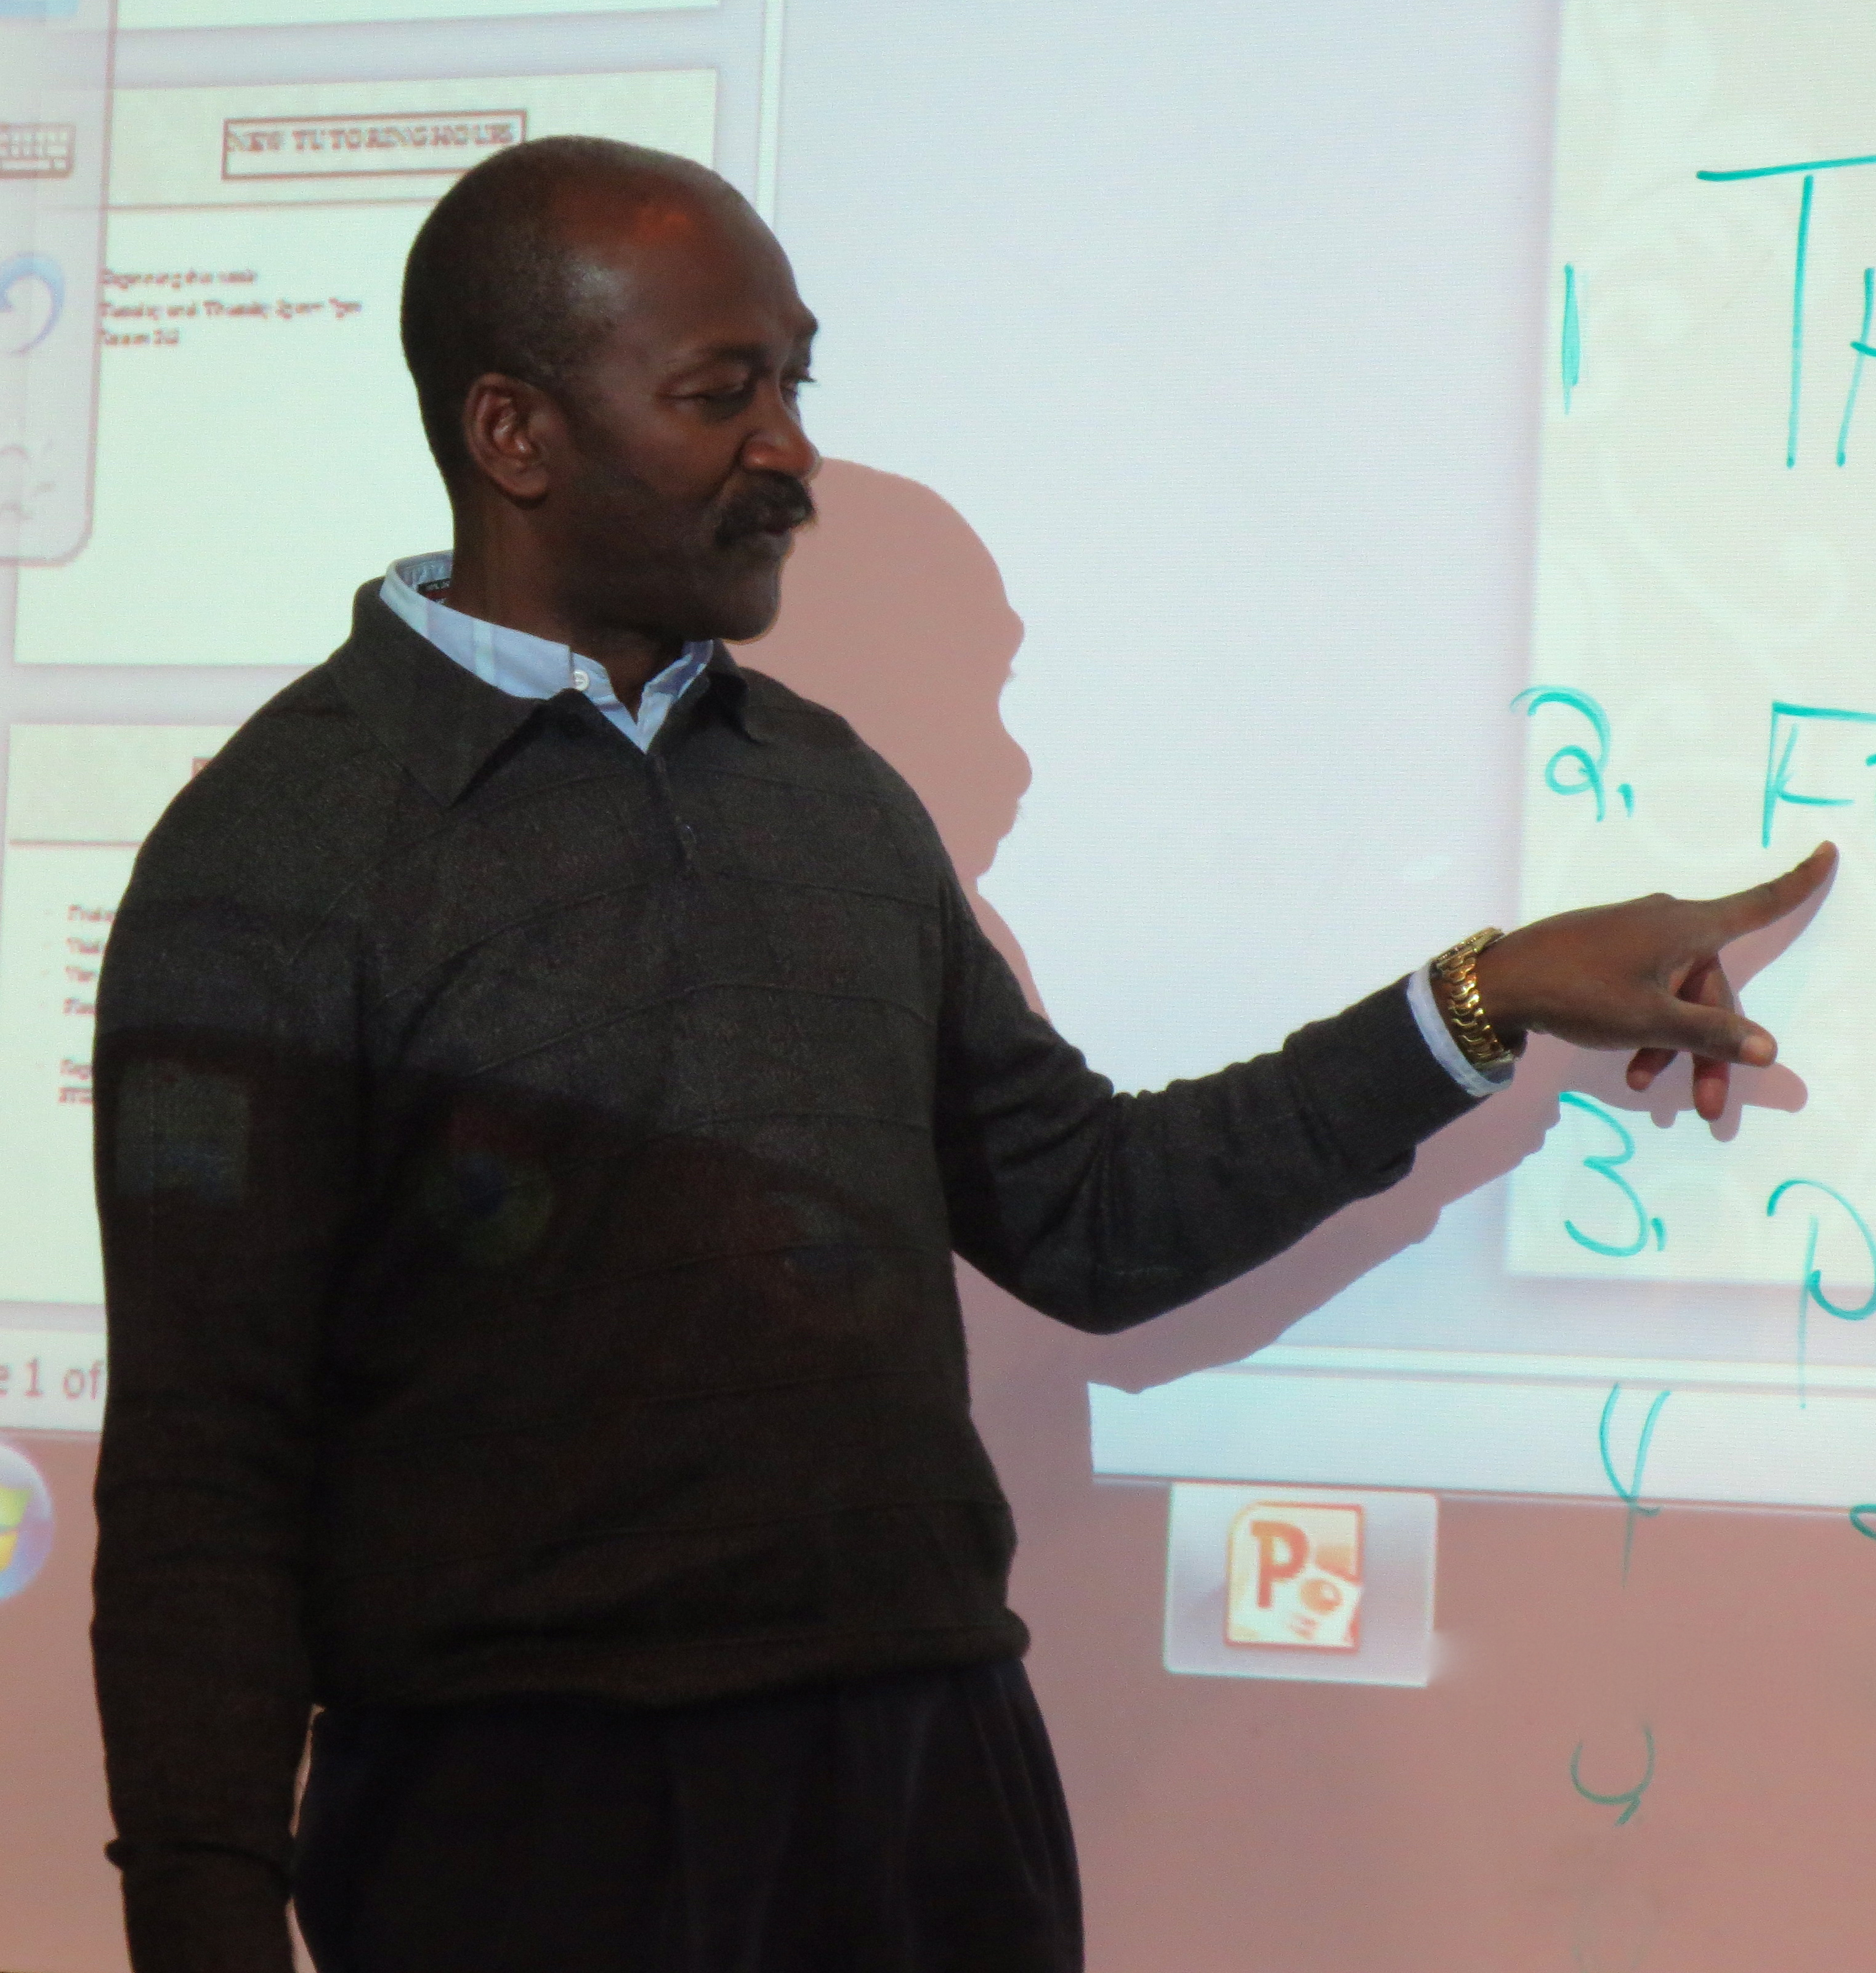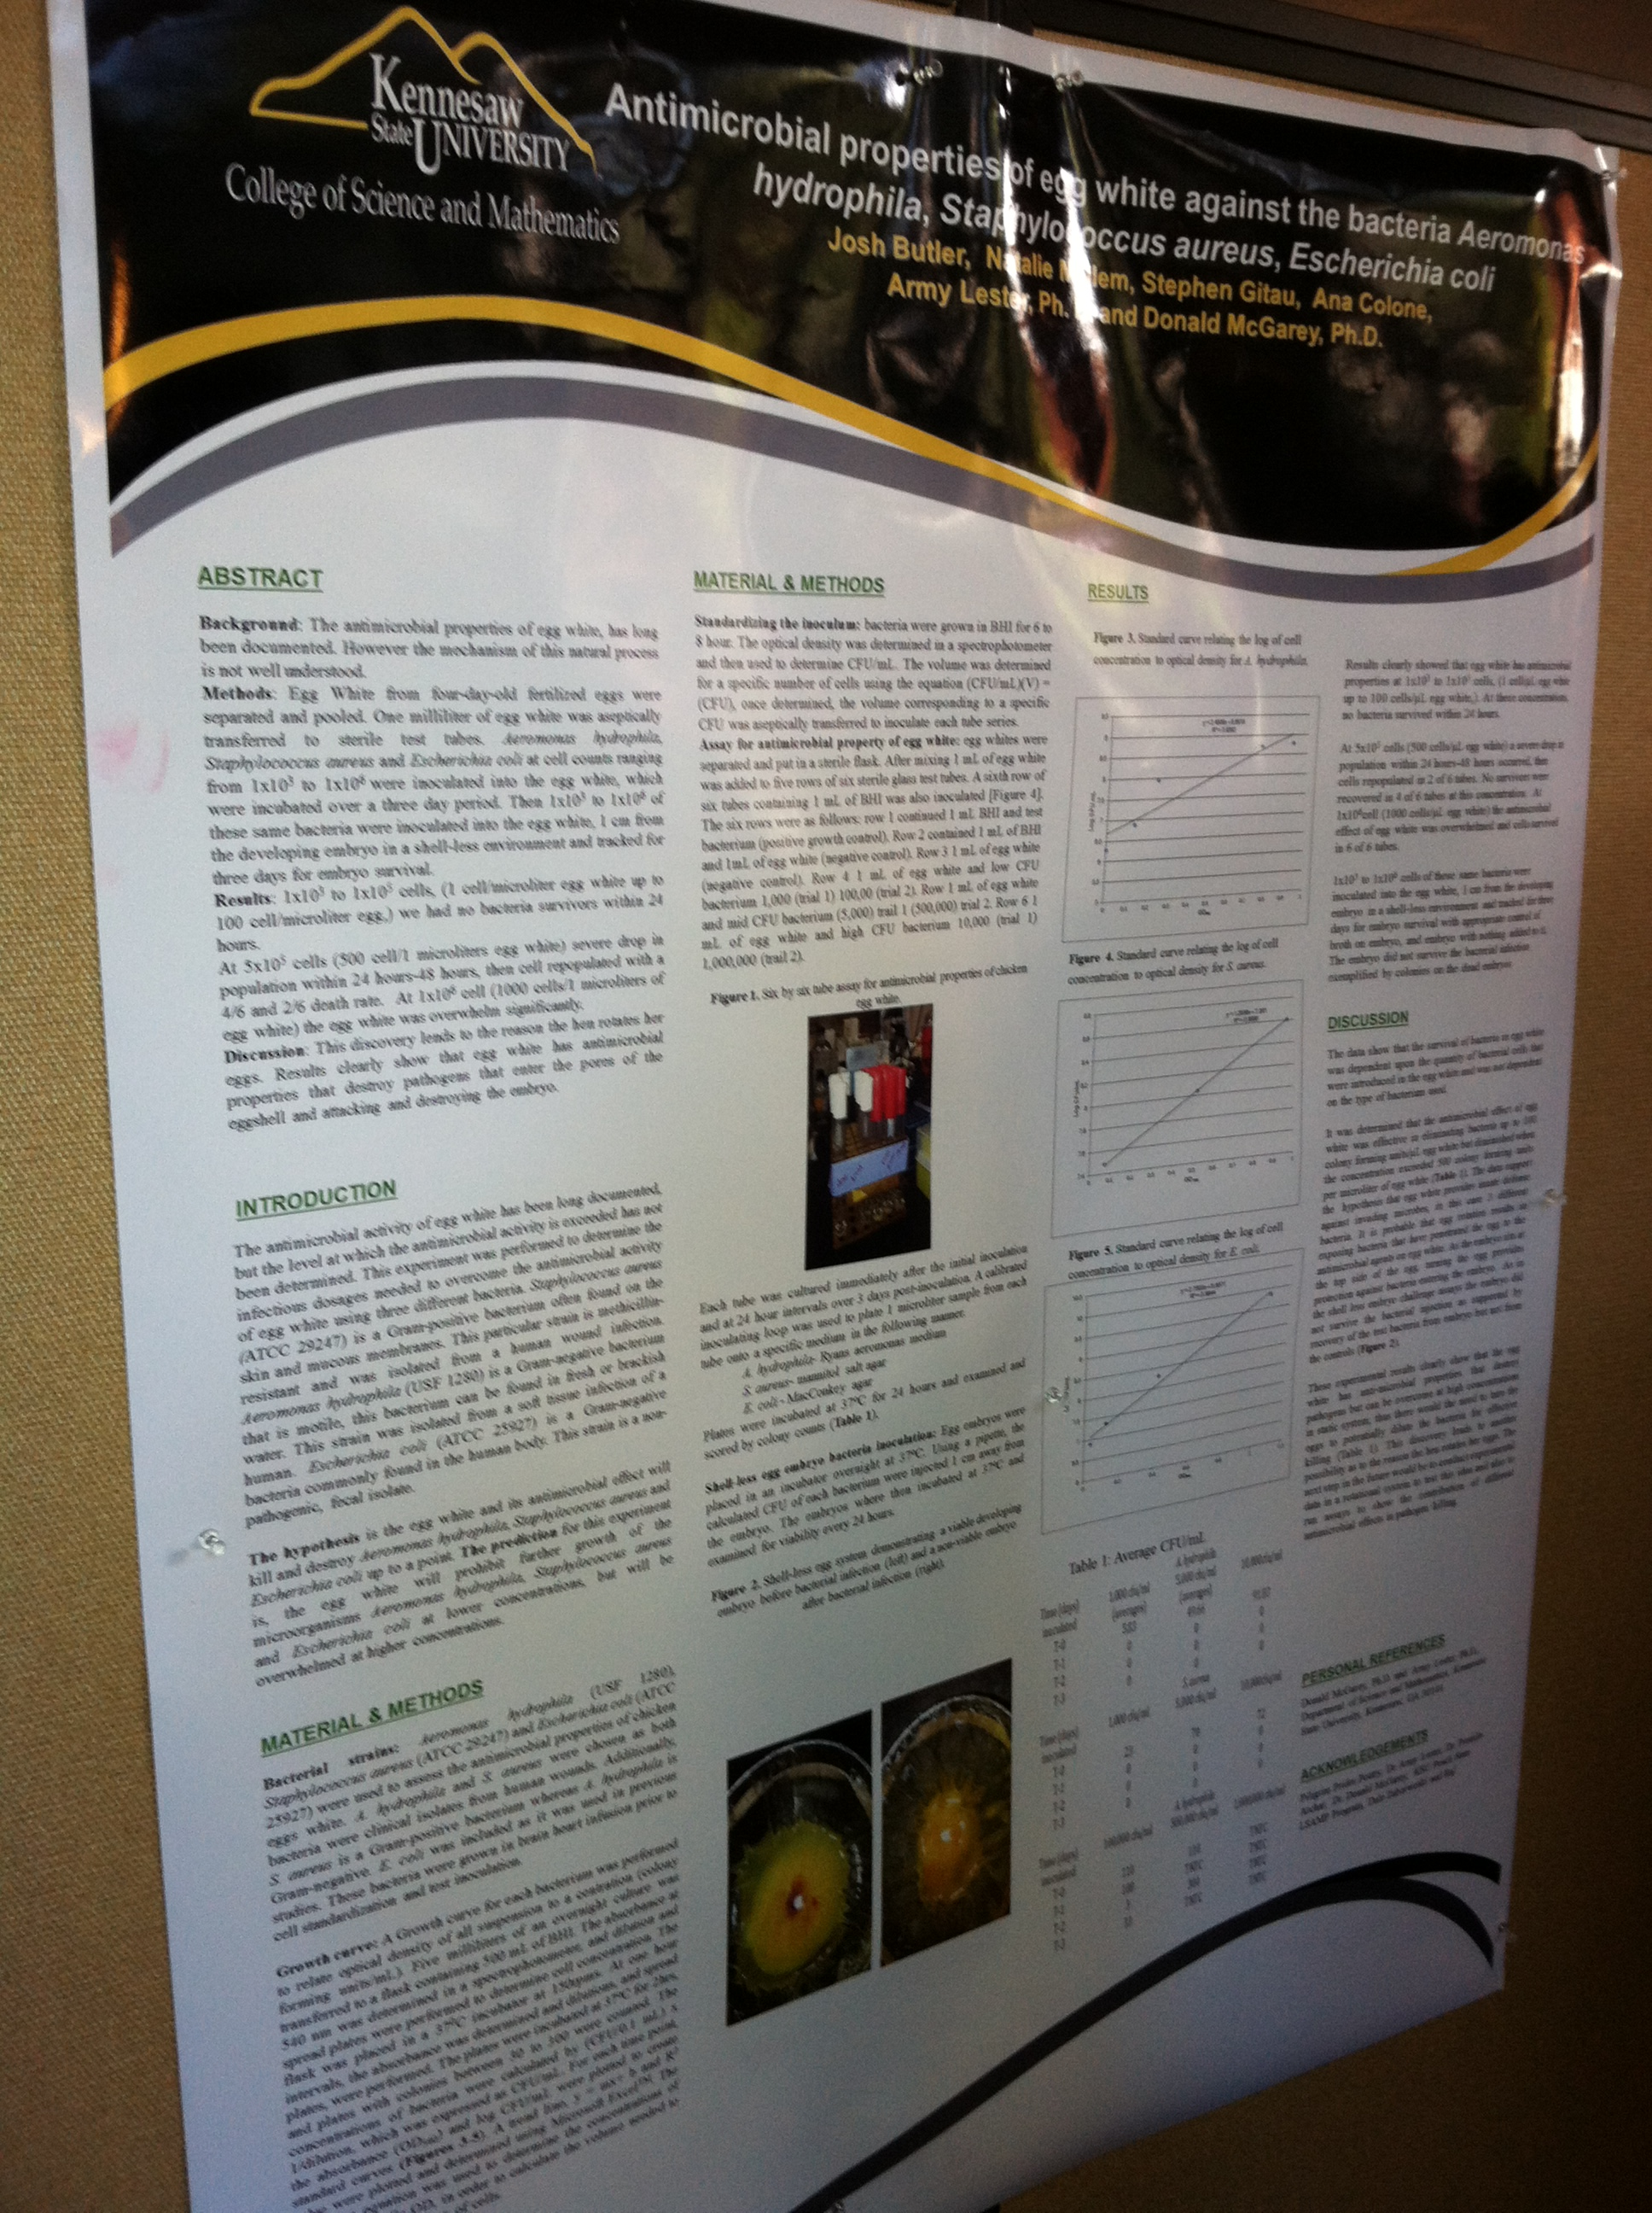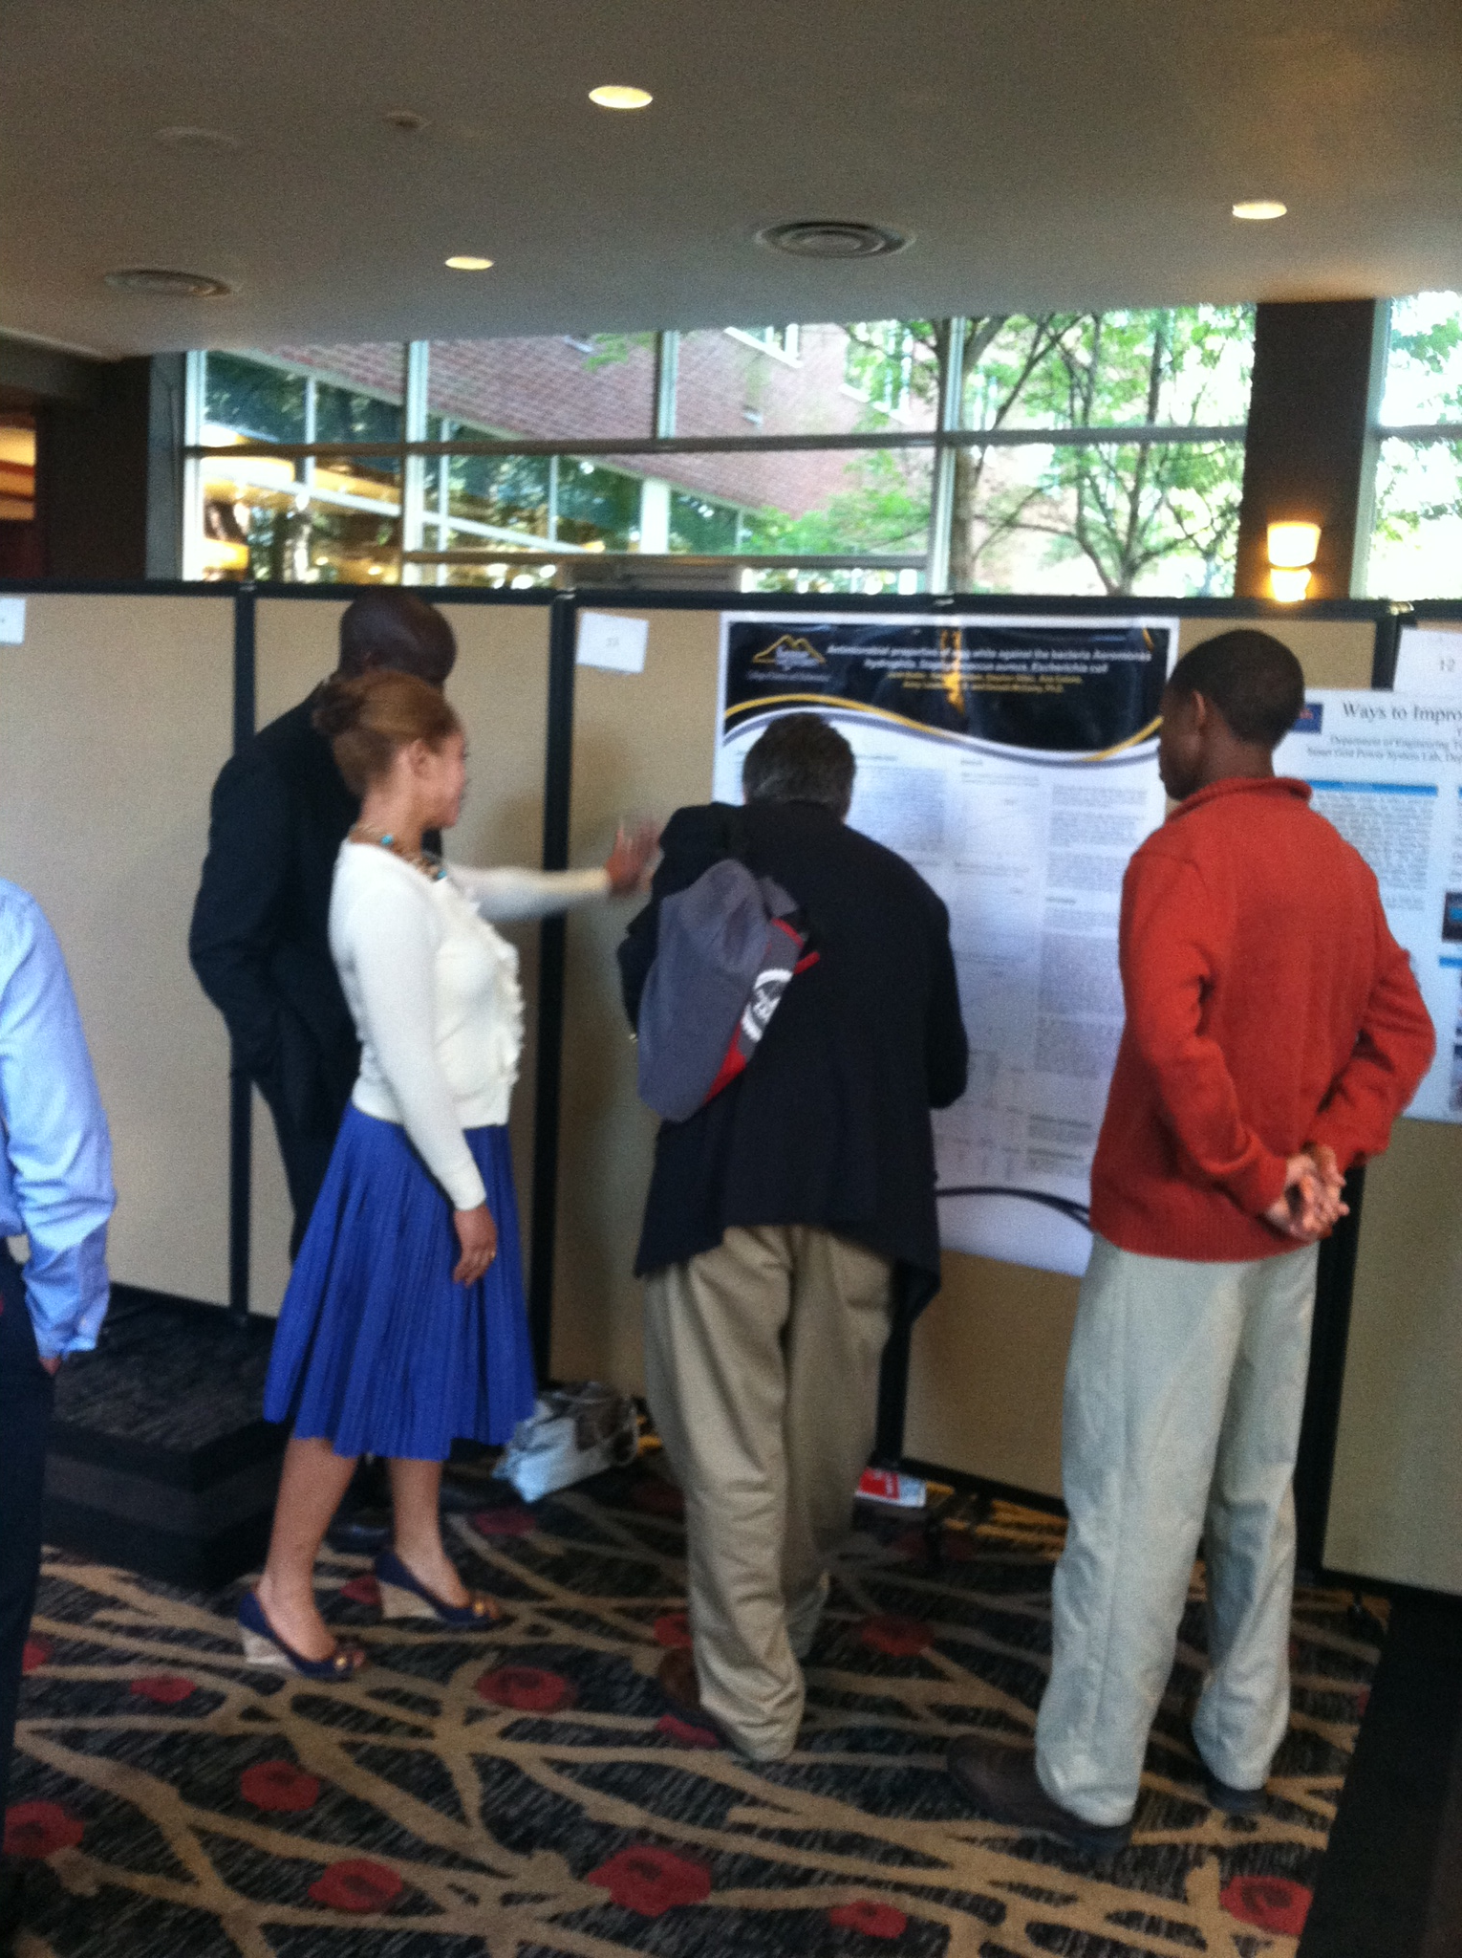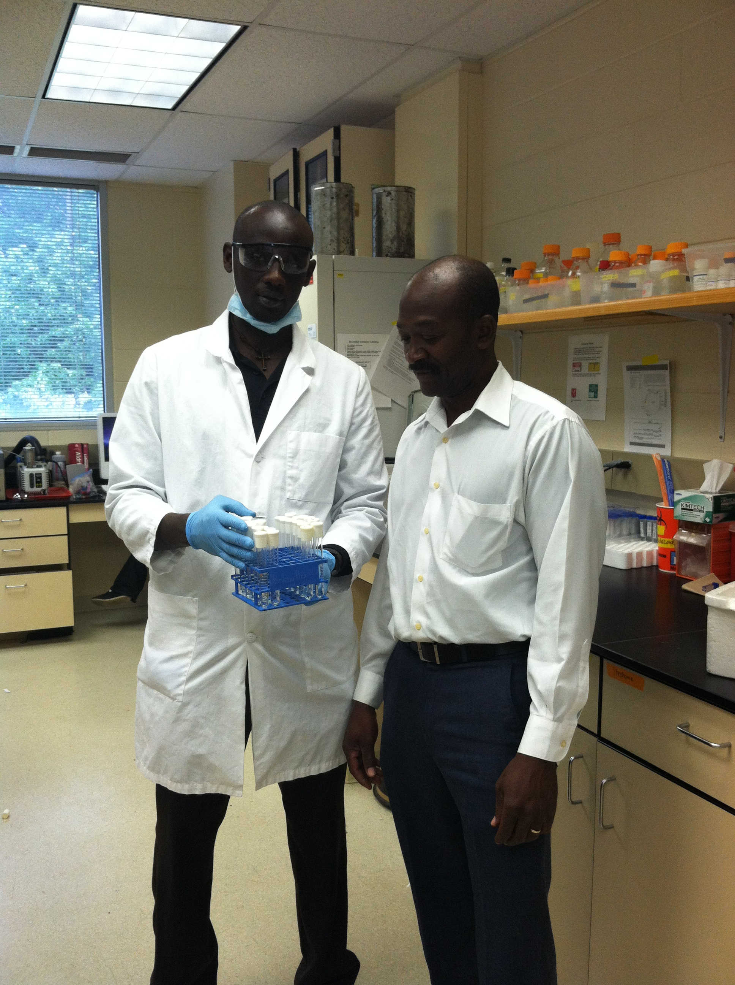

2/14/2014 University of California Berkeley Developmental Biologist

Dr. David Weisblat

3/21/2014 Georgia Perimeter Campus Visit

4/8/2014 STEM Closing Ceremony

Guest Speaker Peach State LSAMP Director Dr. Angela Birkes

4/12/2014 Brigadier General Clarence Turner

U.S. Army Corps of Engineers

STEMulating Events

#### Kennesaw State University STEM Scholar’s Program

Kennesaw State University STEM Scholar’s program is commitment to academics enrichment, outreach, research opportunities and leadership for underrepresented minority. Pg.5

1

STEMulating News

Issue 2, April 4, 2014

**The NSF/LSAMP and Georgia Space Grant Consortium, NASA Program**

**Director- Dr. Army Lester & Co-Director- Dr. PN Achar**

***The NSF/LSAMP (2011-2016)***

***The ultimate goal of the program is to increase the number of minorities contributing to advancing the frontiers of research and education in STEM fields. LSAMP is a multi-disciplinary comprehensive program. Success of the LSAMP program has been measured by its ability to cause a significant increase in the number of students, particularly those drawn from populations which are currently underserved in science and engineering fields, who graduate with baccalaureate degrees in STEM fields. The program goals are accomplished through the formation of Alliances with other Academic Intuition.***

**The Peach State Louis Stokes Alliance for Minority Participation (Peach State LSAMP) program:**

* The Louis Stokes Alliances for Minority Participation (LSAMP) program is aimed at increasing the quality and quantity of students successfully completing science, technology, engineering and mathematics (STEM) baccalaureate degree programs, and increasing the number of students interested in, academically qualified for and matriculated into programs of graduate study.
* LSAMP is a collaborative alliance with University of Georgia (UGA) as the lead, Fort Valley State University, Savannah State University, Southern Polytechnic State University, Bainbridge College, and Georgia Perimeter College, Georgia Tech and Kennesaw State University with NSF/LSAMP grant of $5-million/annum award.

**Measurable goals and outcomes for the next five years using academic year 2009 data as the baseline:**

* 1. Increase minority STEM enrollment and baccalaureate degree completion by 30%
* 2. Increase the percentage of LSAMP students who participate in STEM research or an external internship as an undergraduate student by 25%
* 3. Increase the percentage of LSAMP scholars who transfer to a 4-year institution after completing part two-year program by 25%
* 4. Increase the number of students who pursue STEM graduate programs by 30%
* Engage STEM scholars in Academic Enrichment, Community Outreach and Research Activities

**Goals of our Academic Enrichment activities are:**

* To help KSU STEM majors to improve their knowledge on science courses specially gateway courses and “difficult courses” and improve their grades.
* To give opportunity to our senior students to build leadership qualities.

**The goal of our Research activities are:**

* To help KSU STEM majors gain research experiences and assists them with presentations at local, state, national and international conferences.
* To ensure that students are engaged consistently in research at some level including shadowing to gain research experience prior to registration for undergrad research.

**The goal of our Outreach activities is :**

* To help better prepare pre-college students, teachers, and family with the knowledge and skills needed to prepare pre-college students for the challenges of STEM majors in college**.**

**KSU NSF/LSAMP Director’s Corner**

Dr. Army Lester, Professor Biology, joined the faculty of Kennesaw State in 1985 and has since worked tirelessly to ensure that every student has an opportunity to succeed. He states that he is extremely excited about his role as Director of the STEM Scholars Program in that much of what he has have done in his many years of teaching and service has been like a training camp for this position. As a Director, he is working to help establish a network of faculty, students, staff and the community to create an environment that fosters the total success of all of our STEM majors. His focus has been to mentor STEM majors to help them attend the success needed for the graduate program of their dream.

He surrounds his students in an environment that is filled with the resources required to meet their academic needs. He treats diversity as a highly valued resource because he believes that every student brings different leadership qualities and traits that could benefit the entire group. Students work with faculty and community members to create a clear description of what resources the students need and want, and how to use those resources to ensure academic success.

He states, "mentoring”, or as I view it, teaching with a personal compassion for the well-being of another, is one of the most powerful tools of education.  When one talks about mentoring, it almost immediately conjures up a notion of a caring individual who uses personal knowledge and wisdom to help another become all that she/he can be. Great mentors are able to see the potential of their protégées and help bring out the best in them.  Mentoring is a very deliberate act that happens when a person is willing to use personal gains to empower another who might just someday become more powerful than the mentor. Finally, we must make a commitment to ourselves; our protégées and we will be there for them no matter what. Mentoring is a highly contagious and mutually enjoyable experience.  All it takes is one person with the heart and compassion to ignite a world of difference.  Serving as a mentor is one of the most enjoyable elements of my career as a STEM educator and scientist."

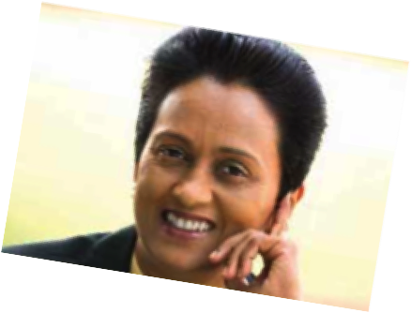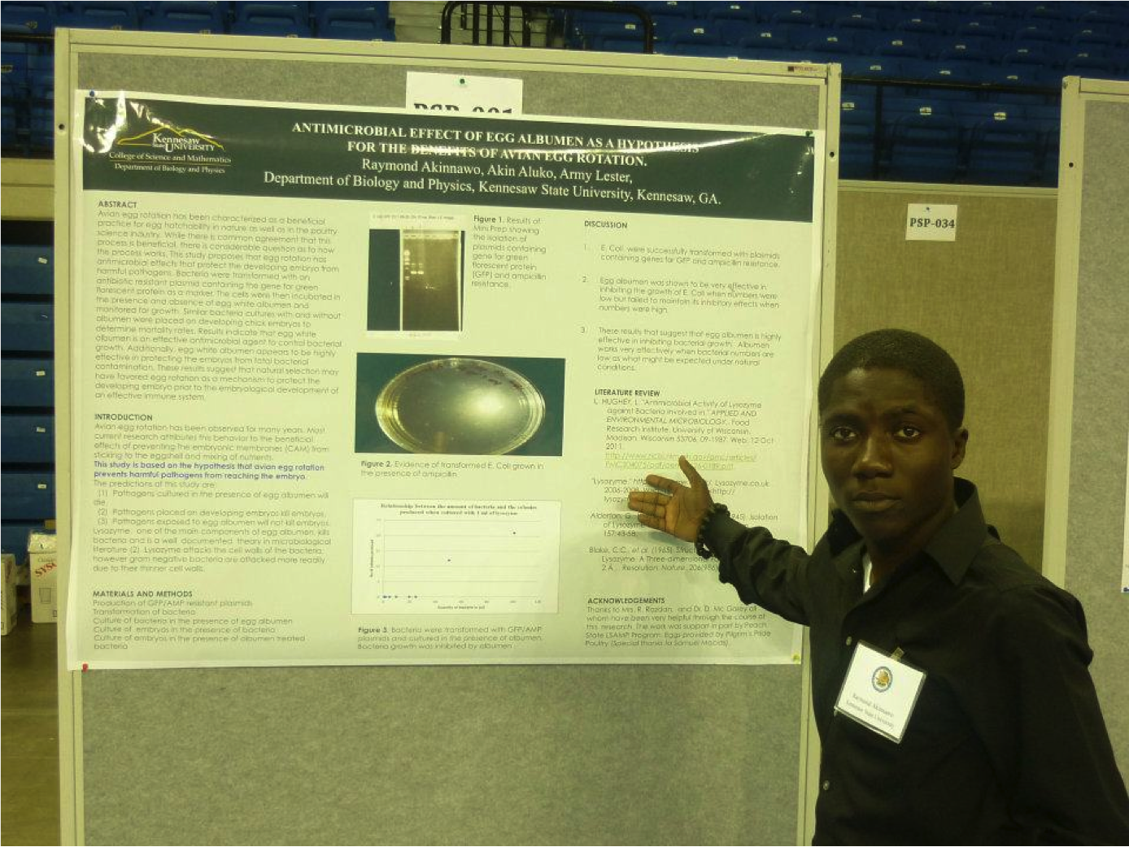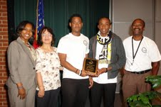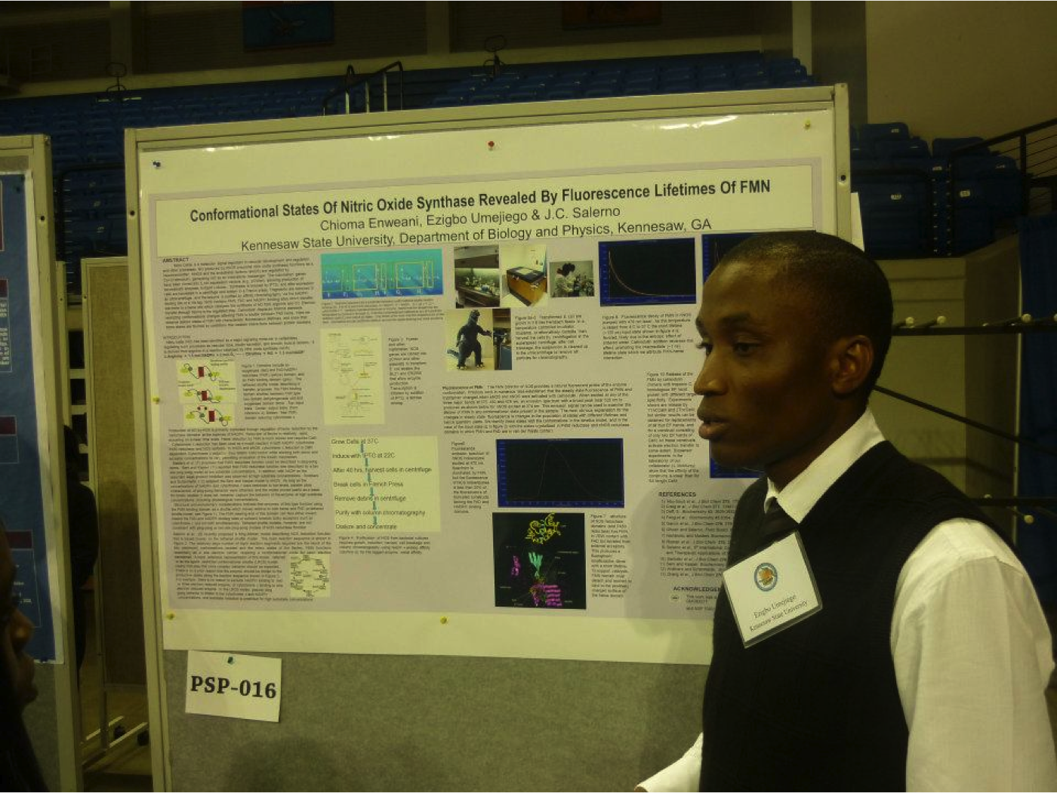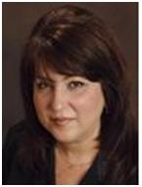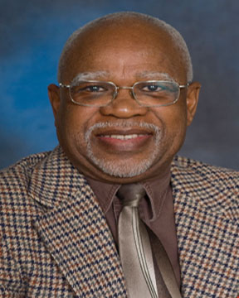

Dr. Achar is an Associate Professor of Biotechnology. She has supervised several masters, doctoral, and postdoctoral students in the fields of Molecular Biology and Biotechnology with specific focus on host-pathogen interactions. She is currently working on the early detection of carcinogenic mold in peanuts by molecular methods. She is in the process of developing transgenic peanuts with lower levels of afflatoxin through gene manipulation and transformation.

Dr. Achar is a vital member of the STEM Scholar program at KSU. She served as research coordinator of the STEM scholars under the NSF/LSAMP and NASA grants in 2011 and currently, as a Co-director of these two programs she oversees the day-to-day running of these two programs. Through these two grants, students have benefitted immensely by receiving stipends for getting involved in Research, Academic Enrichment, Community Outreach and Leadership activities. STEM scholars active in undergraduate research get the opportunity to attend regular research meetings, conferences, symposiums, academic meetings and field trips. Through our Academic Enrichment program, our senior STEM scholars have assisted several freshmen and sophomores in gateway courses with Supplementary Instructions (SI) and hands-on Lab skills. Through our Community Outreach activities, our Summer Camps, fully funded by these two grants, hold a one-week lab oriented sessions for middle schools and two-week lab sessions for high schools. These sessions are students’ driven and our seniors get the opportunity to show their leadership qualities and transfer knowledge and skills to the pre-college students.

In addition, NSF/LSAMP grant fully or partially support students’ summer internship at KSU or other institutions. A new addition to assisting minority students by this grant is the Study Abroad Travel Awards (2013), which gives our students an “out of classroom experience” and with global travel, they learn the diversity in arts, culture, religion, and languages of another country.

## **KSU NSF/ LSAMP Co-Director’s Corner**



**LSAMP Academic Enrichment Coordinator 2014-Present**

Melanie Griffin Ph.D., Professor

Leadership Coordinator LSAMP/STEM

Dr. Sarah M. North is a faculty member of Computer Science Department at Kennesaw State University. She has been teaching, conducting research, and mentoring STEM students, and providing community service in Computing for over 27 years at higher education institutions.

Dr. North’s research focuses on Educational Technology and Leadership Administration, Information Security Education, Human-Computer Interaction, and Cognitive Science.

Dr. North has been research mentor with LSAMP program for several years in prior institution. She took a leadership by securing funds from Boeing Company, National Security Agency (NSA) and Department of Defense (DoD) to support outreach and K-12 education programs in support of community for many year. Dr. North is the new community outreach coordinator and also provides service to STEM program as a leadership coordinator, work with STEM student’s officers to solicit and mentor other KSU students involving in STEM activities. She also is the research mentor for LSAMP Computer Science students.

**LSAMP Community Outreach &Leadership Development 2012-2014**

Sarah M. North Ph.D., Assistant Professor

Leadership Coordinator LSAMP/STEM

Academics Research Outreach Leadership

**LSAMP Conference Research Coordinator**

**2012-2014**

Huggins Msimanga Ph.D., Professor

Research Coordinator, LSAMP/STEM

Dr. Huggins Z. Msimanga is Professor of Analytical/Forensic chemistry in the College of Science and Mathematics. He has devoted many years of experience teaching/mentoring undergraduate students, with over 40 students advised in research activities. His research focuses on the application of multivariate analysis techniques to develop calibration matrices for analyzing complex mixtures (medicinal drugs) and to profile drug samples. His other area of research involves studying the chemical composition of plant medicines whose chemical composition is not well known. Over the years, Dr. Msimanga has remotely participated in summer programs involving high school students. Since fall 2012, Dr. Msimanga is serving as research coordinator of the STEM Scholars Program at KSU.

In keeping with the aspirations of STEM programs across the nation, Dr. Msimanga’s goal is to encourage students do very well in their course work and to get involved with high-quality research, an excellent preparation for graduate studies in the STEM area.

**LSAMP Research Coordinator 2014-Present**

David Joffe, Ph.D., Professor

Research Coordinator, LSAMP/STEM

Academics Research Outreach Leadership

STEM students with KSU LSAMP/NASA STEM Director Dr. Army Lester Biology Professor and Marina Koether Chemistry Professor enjoying dinner at Sonny’s BBQ after their poster and oral presentation at Georgia Academy of Science conference.

8

Pellentesque venenatis.

Issue 1, August 8, 2013

STEMulating News